New Books in our Library
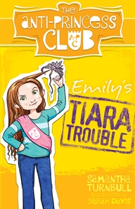
Emily’s Tiara Trouble- The Anti-Princess Club 1 by Samantha Turnball
Genre: Classic fiction (Children's/Teenage)
Talented ten-year-olds Emily, Bella, Chloe and Grace are sick of adults trying to turn them into helpless princesses.
When maths whiz Emily Martin's mother enters her in the local beauty pageant, it's the last straw - the four friends form the Anti-Princess Club, with the motto WE DON'T NEED RESCUING.
Can they use their awesome skills to show the world that girls want to be valued for more than what they see in the mirror?

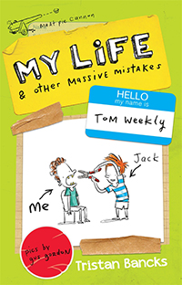
My Life and Other Massive Mistakes By: Tristan Bancks
Genre: - Humorous stories (Children's/Teenage)
Have you ever helped your pop escape from a nursing home?
Does your teacher have a problem with his bowels?
Is your sister an evil genius and criminal mastermind? Have you ever mined your teeth for cash?
Do you want to know where all the lost socks go?
Is there a girl or boy at school who's desperate to kiss you?
And do you know someone with the worst case of nits in world history?
I do. I'm Tom Weekly and this is the third book in my weird, funny, sometimes gross life story.

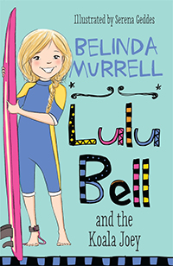
Lulu Bell and Koala Joey By: Belinda Murrell
Genre: - Animal stories (Children's/Teenage)
Lulu Bell's beach holiday is about to begin!
Lulu can't wait for her holiday at Tarni Beach to begin.
She has a new pink surfboard and Dad is going to teach her to surf. Lulu and her friend Zac like to spot wildlife in the bush nearby. But bulldozers have arrived and the trees might soon be gone.
What will happen to the mummy koala and her joey if all the trees are taken away? Lulu needs to work out how to save the koalas' home!

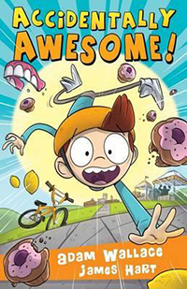
Accidently Awesome By: Adam Wallace
Jackson Payne is clumsy.
Like, really clumsy.
Like really, really, really, really, clumsy.
Like...well, you get the idea.
But every time he’s clumsy, awesome things happen.
The problem is, Jackson is over it.
He only wants to be a hero on purpose.
But how do you stop being a fluke?
It’s action-packed, it’s laugh out loud funny and best of all, it’s awesome.

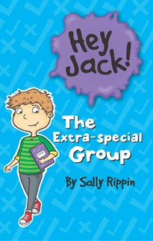
The Extra-special Group – Hey Jack By: Chris Morphew
Genre: - General fiction (Children's/Teenage)
Jack has to go to a special class for help with his reading. He is extremely embarrassed about this and worries what everyone else will think. He worries that they will all think he is stupid.
Jack doesn’t even tell Billie the truth. He knows he should and feels bad about it.
Jack learns some very valuable lessons about getting help and confiding in your friends.
This series really is fantastic for your emerging readers.

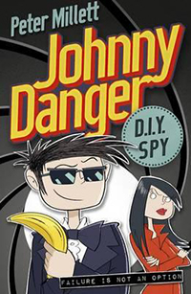
Johnny Danger DIY Spy By: Peter Millett
Genre: General fiction (Children's/Teenage)
Imagine you are a would-be primary school age spy when you are suddenly taken to MI6 to save the world from the evil Dr Disaster.
That’s what happens to Johnny Danger!
All of a sudden, he has at his disposal all of the ingenious gadgets that he had dreamed of at home. Bubblegum parachutes, bogey bombs and the coolest car are all Johnny’s, as is a whole lot of money. But will MI6 realise Johnny is not a master spy or can he miraculously fluke stopping Dr Disaster?
I’m sure you can guess the answer!
Younger 9-12 year old boys will enjoy the nonsense, the gadgets and Johnny’s wonderful attitude in this Australian written title, the first in a new series.

